Rayat Shikshan Sanstha’s
Dada Patil Mahavidyalaya, Karjat
Dist:Ahilyanagar



“AI Resume Analysis”

Submitted in Practical fulfillment of the requirement of the degree

BBA(Computer Application)

Submitted By
Wagh Tanshri Mukesh.
Sonawane Pragati Santosh.

University of Pune,2025-26

“AI Resume Analysis”

By

Wagh Tanshri Mukesh.
Sonawane Pragati Santosh

Savitribai Phule Pune University ,Pune Bachelor of Computer Application

Dada Patil Mahavidyalaya, Karjat
Dist:Ahilyanagar
2025-2026

Rayat Shikshan Sanstha’s
Dada Patil Mahavidyalaya, Karjat
Dist:Ahilyanagar
Department of Computer Application
(Estd. 2007-08)
Bachelor of Business Administration (Computer Application)


Project Completion Certificate

This to certify that Wagh Tanshri Mukesh and Sonawane Pragati Santosh. student of Dada Patil Mahavidyalaya, Karjat, Dist- Ahmednagar has successfully completed the project work as prescribed by the Savitribai Phule Pune University, Pune in the partial fulfillment requirements of the Bachelor of Business Administration(Computer Application) Program Year 2026-2027 5th Semester.
The project work titled as “AI Resume Analysis” has been based on project work which was carried out at establishment of Railway Reservation/organization.

Project Guide: Head of Department
Ms. Shelke Mam Prof. Mandlik Sir

Internal Examiner: External Examiner:

Date: / /2026 Place: Karjat

ACKNOWLEDGEMENT

A Successful project is the result of meticulous organization and well-coordinated teamwork. We would like to extend our heartfelt gratitude to everyone who contributed their valuable efforts during the course of this project. We are deeply thankful to our honorable principal, Dr. Sanjay Nagarkar Sir, for inspiring us to gather professional knowledge and material. Without his guidance, completing this project would have been impossible.
We would also like to express our sincere thanks to our Head of Department, Prof. Mandlik Sir, and our project guide Prof. Miss Shelke Ma’am, for their continuous support, insightful suggestions, and guidance throughout the course of the project.
Lastly, we would like to acknowledge the contributions of our partners in this venture, Miss. Wagh Tanshri Mukesh, Miss. Sonawane Pragati Santosh. Their dedication, teamwork, and commitment to the success of this File Conversion website project have been instrumental throughout the development of the project.

Yours Faithfully,
Wagh Tanshri Mukesh
Sonawane Pragati Santosh

DECLARATION

To,
The Principal,
Dada Patil Mahavidyalaya, Karjat,
Dist. Ahilyanagar,
PIN- 414402.
Respected Sir,
We are Miss. Wagh Tanshri & Miss. Sonawane Pragati
“AI Resume Analysis” developed and submitted under the guidance of Prof. Ms. Shelke Ma’am. The system presented here is our own work and not taken from any other sources.

Date: / / 2026
Place: Karjat,

Yours Sincerely,
Miss. Wagh Tanshri Mukesh
Miss. Sonawane Pragati Santosh

Index

Sr. No. | Content | Page No.
1. | Project Title | 1-2
2. | Certificate | 3
3. | Declaration | 4
4. | Acknowledgement | 5
5. | Abstraction | 7
6. | Introduction | 8-10
7. | System analysis | 11-13
8. | System design | 14-18
9. | Implementation details | 19-20
10. | System Output and Validation | 21-22
11. | Conclusion and Recommendation Limitation & Future Scope | 23
12. | Bibliography | 35

ABSTRACT

AI Resume Analyzer is a web-based application designed to help recruiters analyze and compare resumes according to specific job requirements. In the recruitment process, recruiters often receive a large number of resumes for a single job opening. Manually reviewing every resume can be time-consuming and difficult.
The main objective of this project is to simplify the initial resume screening process by automating resume text extraction, skill matching, score calculation, and candidate ranking.
The recruiter first enters the job title, required skills, and job description into the system. After that, the recruiter uploads one or multiple resumes in PDF or DOCX format. The system extracts readable text from the uploaded resumes and compares it with the selected job requirements.
The system calculates an ATS-style score out of 100 using five criteria: Skills Match, Experience, Education, Certifications, and Keywords and Format. The analyzed resumes are then ranked from the highest score to the lowest score.
The application uses HTML, CSS, and JavaScript for the frontend, Python with Flask for the backend, and MySQL for database management. The system aims to reduce manual screening effort and help recruiters identify potentially suitable candidates more efficiently.

INTRODUCTION
AI Resume Analyzer is a recruitment-support application that helps recruiters compare candidate resumes with job requirements. It automates parts of the initial screening process and displays a score-based ranking of the uploaded resumes. The system is designed to make resume screening more organized, consistent, and time-efficient.

- Motivation: organizations receive many resumes for different job positions. Checking every resume manually requires considerable time and effort. Recruiters must identify relevant skills, qualifications, experience, and certifications from each resume. Comparing many candidates manually may also lead to inconsistent results. Therefore, the motivation behind developing AI Resume Analyzer is to create a system that automatically analyzes resumes, compares them with job requirements, and ranks candidates according to their matching scores.

- Problem Statement: The traditional resume screening process is time-consuming because recruiters must manually read and compare multiple resumes with job descriptions. It can be difficult to identify the most relevant candidates quickly, especially when the number of applications is large. The proposed system addresses this problem by extracting resume text, matching it against job requirements, calculating ATS-style scores, and ranking candidates from highest to lowest score.

- Purpose, Objectives and Goals: The main purpose of AI Resume Analyzer is to simplify the initial resume screening process.

- Objectives:
- To provide an interface for entering job requirements.
- To allow recruiters to upload one or multiple resumes.
- To extract readable text from PDF and DOCX resumes.
- To compare resume content with job requirements.
- To analyze skills, experience, education, certifications, and relevant keywords.
- To calculate an ATS-style score out of 100.
- To rank candidates according to their scores.
- To store user details, job information, resume records, and analysis results in a MySQL database.
- To reduce repetitive manual work during the initial screening process.

- Literature Survey: Applicant Tracking Systems (ATS) are commonly used in recruitment to organize job applications and support candidate screening. Resume parsing is a technique used to extract information such as skills, education, experience, and contact details from resume documents. Keyword-based matching compares the words and skills found in a resume with those mentioned in a job description. Weighted scoring assigns different importance levels to various criteria and combines them into a final score.AI Resume Analyzer applies these general concepts in an academic web application. It uses document text extraction, rule-based matching, weighted scoring, and candidate ranking to support the initial screening process. The current system uses programmed matching rules. Its results depend on the quality of the resume text and the job requirements entered by the recruiter.

- Project Scope: The scope of the project includes:
- User registration and login.
- Entering job title, required skills, and job description.
- Uploading one or multiple resumes.
- Supporting PDF and DOCX resume formats.
- Extracting readable text from resumes.
- Matching resume information with job requirements.
- Calculating ATS-style scores.
- Displaying category-wise score breakdowns.
- Ranking candidates from highest to lowest score.
- Storing information and analysis results in a MySQL database.

SYSTEM ANALYSIS
- Existing Systems: In the traditional recruitment process, recruiters manually open resumes, read the content, identify relevant skills, and compare candidate qualifications with the job description. Some existing recruitment platforms provide resume parsing, application management, candidate filtering, and automated screening features. However, the available features and accuracy vary depending on the system.

- Scope and Limitations of Existing Systems: Manual resume screening has the following limitations:
- It requires considerable time and effort.
- Comparing a large number of resumes can be difficult.
- Different recruiters may evaluate resumes differently.
- Identifying relevant skills across many documents can be repetitive.
- Organizing and ranking candidates manually may become complicated.
Automated screening tools can reduce some of these difficulties, but basic keyword-based systems may fail to understand context, synonyms, or skills expressed using different terminology. AI Resume Analyzer provides a simple system for comparing and ranking resumes using predefined rules and scoring criteria.
- Project Perspective and Features: AI Resume Analyzer is designed as a web-based recruitment-support system.

Main features:
User Authentication: Allows users to register and log in.
- Job Requirements: Accepts job title, required skills, and job description.
- Resume Upload: Allows uploading multiple resumes in supported formats.
- Resume Text Extraction: Extracts readable text from PDF and DOCX files.
- Skills Matching: Compares resume skills with required job skills.
- ATS Score Calculation: Calculates a weighted score out of 100.
- Candidate Ranking: Sorts candidates according to their scores.
- Database Management: Stores user, job, resume, and analysis information.
- Analysis Results: Displays the score and ranking for each analyzed resume.

- Stakeholders: The main stakeholders of the project are:
- Recruiter/User: Enters job requirements, uploads resumes, and reviews the analysis results.
- Project Developer: Develops, tests, and maintains the application.
- Project Guide/Faculty: Provides guidance and evaluates the project.
- Candidates: Their resumes may be processed by the system, so their personal information must be handled confidentially.

- Requirement Analysis:
Functional Requirements: Functional requirements describe the operations that the system must perform.
- The system should allow users to register and log in.
- The system should accept job title, required skills, and job description.
- The system should save job requirements in the database.
- The system should generate a unique Job ID for each saved job.
- The system should allow uploading PDF and DOCX resumes.
- The system should extract readable text from uploaded resumes.
- The system should compare resume information with job requirements.
- The system should calculate ATS-style scores.
- The system should rank candidates according to their scores.
- The system should display the analysis results.
- The system should store analysis results in the database.
- Performance Requirements:
- The system should process resumes within a reasonable time.
- It should support multiple resume uploads within the configured limits.
- It should display analysis results clearly.
- It should handle invalid or unreadable files appropriately.
- Its response time should remain reasonable for the expected academic demonstration workload.

SYSTEM DESIGN
System design describes the structure, components, database, and workflow of the application.
- Design Constraints: The project has the following design constraints:
- The system requires Python and Flask for backend processing.
- MySQL must be available for database operations.
- The current upload process supports PDF and DOCX formats.
- Resume text extraction depends on the readability of the uploaded document.
- Scanned PDF files may require Optical Character Recognition (OCR).
- Matching accuracy depends on the resume content and the job description.
- ATS scores are based on programmed scoring rules and may not fully understand the context of every resume.

ERD:
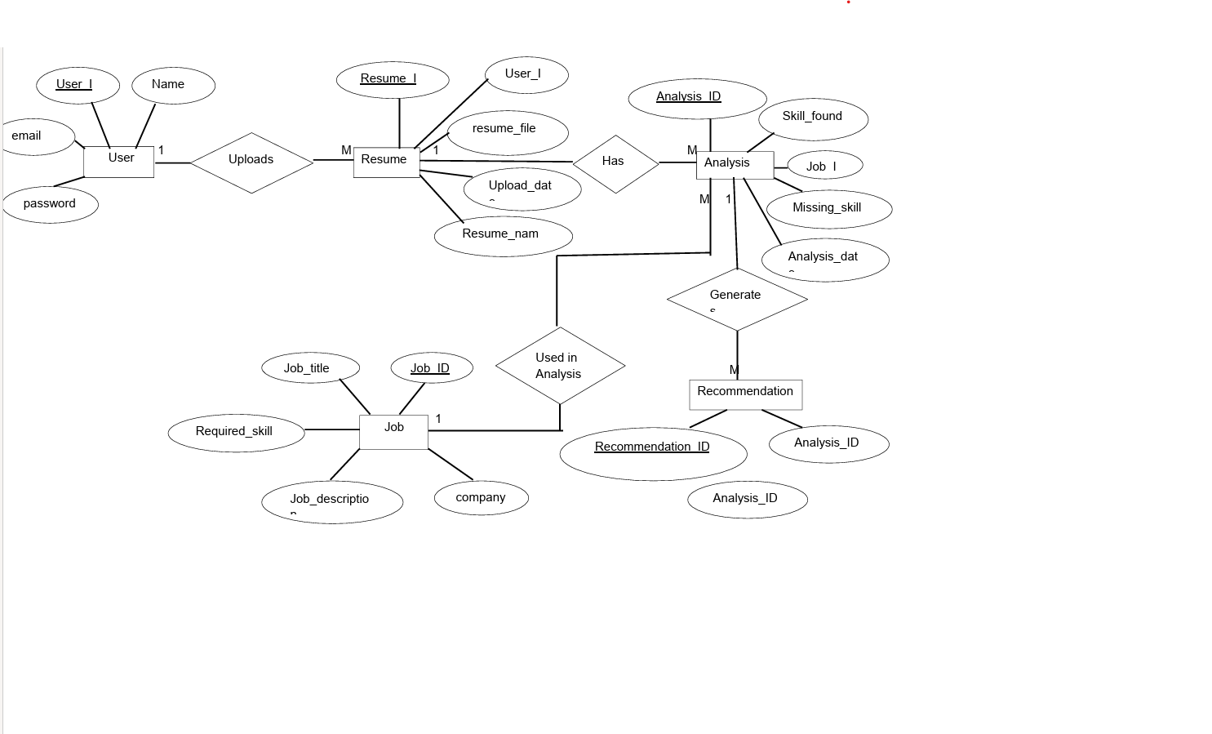

Data Model
User Table :
Field Name | Data Type | Key | Description
User_id | INT | PK | Unique user ID
Name | VARCHAR(100) | - | Name of the user
Email | VARCHAR(100) | UNIQUE | User email address
password | VARCHAR(255) | - | Hashed user password
Created_at | DATETIME | - | Account creation date and time

Jobs Table:
Field Name | Data Type | key | Description
Job_id | INT | PK | Unique job ID
User_id | INT | FK | ID of the user who created the job
Job_title | VARCHAR(150) | - | Title of the job
Required_skills | TEXT | - | Skills required for the job
Job_description | TEXT | - | Description of the job requirements
created_at | DATETIME | - | Date and time when the job was created

Resume Table:

Field Name | Date Type | Key | Description
resume_id | INT | PK | Unique resume ID
User_id | INT | FK | ID of the user who uploaded the resume
file_name | VARCHAR(255) | - | Name of the uploaded resume file
file_path | VARCHAR(500) | - | Storage path of the resume file
Uploaded_at | DATETIME | - | Date and time of resume upload

Analysis Results Table:
Field Name | Data Type | Key | Description
analysis_id | INT | PK | Unique analysis ID
resume | INT | FK | ID of the analyzed resume
Job_id | INT | FK | ID of the job used for matching
ats_score | DECIMAL(5,2) | - | Overall ATS-style score out of 100
Skill_score | DECIMAL(5,2) | - | Score for skills matching out of 40
Experience_score | DECIMAL(5,2) | - | Score for experience out of 20
Education_score | DECIMAL(5,2) | - | Score for education out of 15
Certification_score | DECIMAL(5,2) | - | Score for certification out of 10
Keywords_format_score | DECIMAL(5,2) | - | Score for keywords and format out of 15
Analyzed_at | DATETIME | - | Date and time of resume analysis

Admin Table:
Field Name | Data Type | Key | Description
Admin_id | INT | PK | Unique admin ID
username | VARCHAR(100) | UNIQUE | Administrator username
password | VARCHAR(255) | - | Hashed administrator password

User Interface
Dashboard:
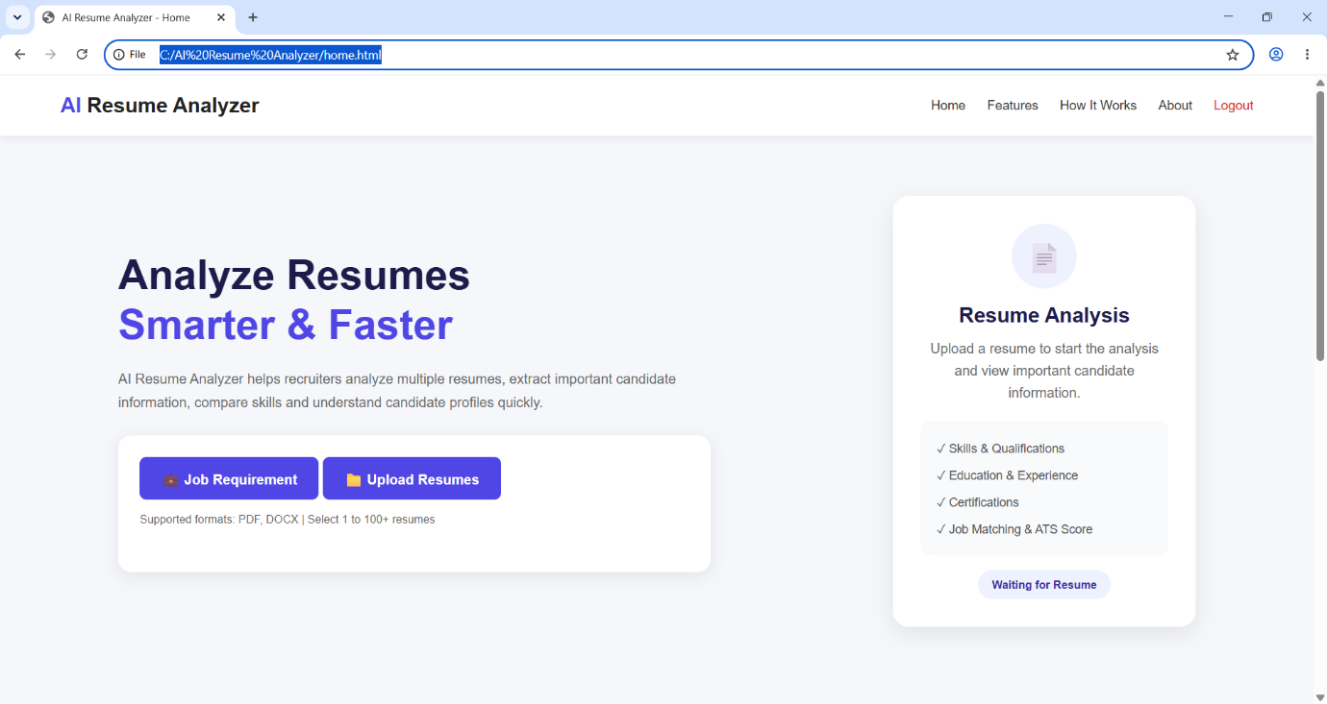
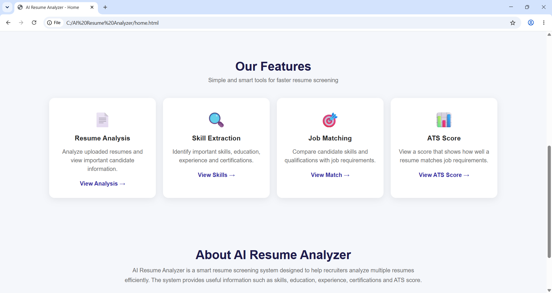

Register Page:
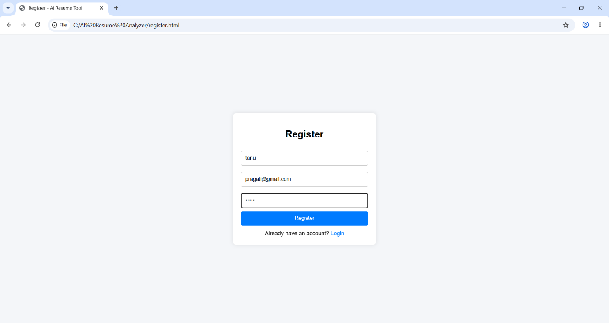

Login Page:
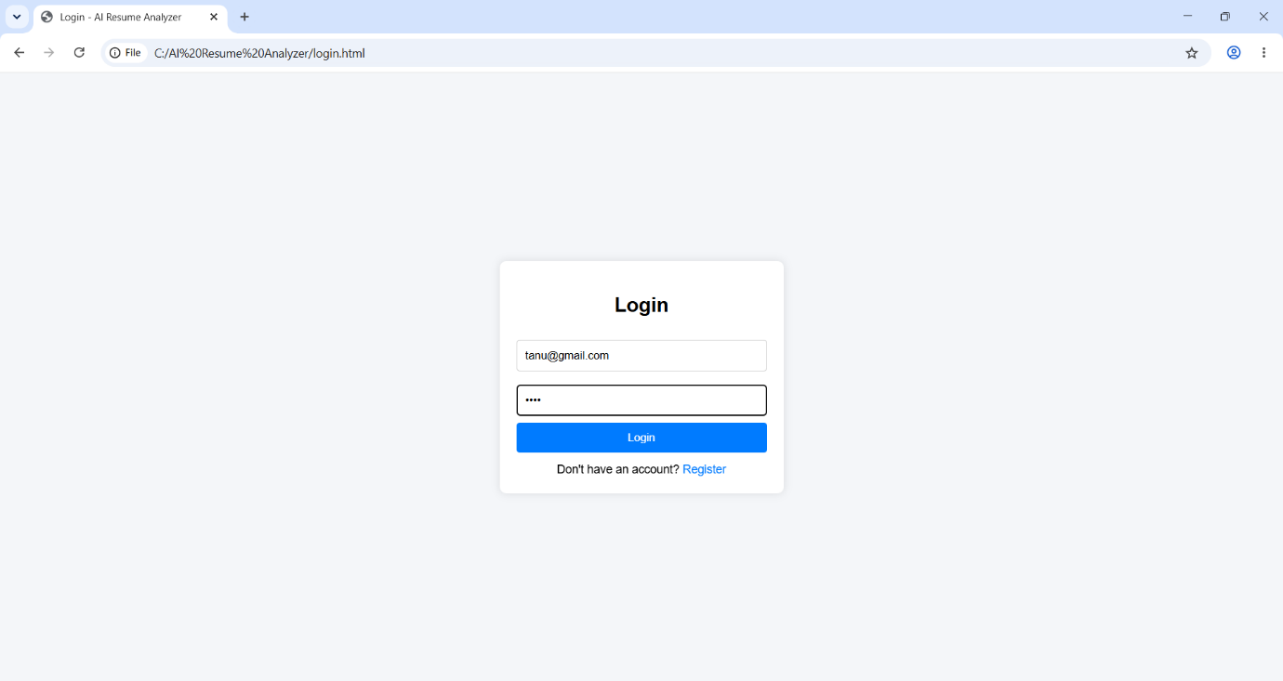

Job Requirement:
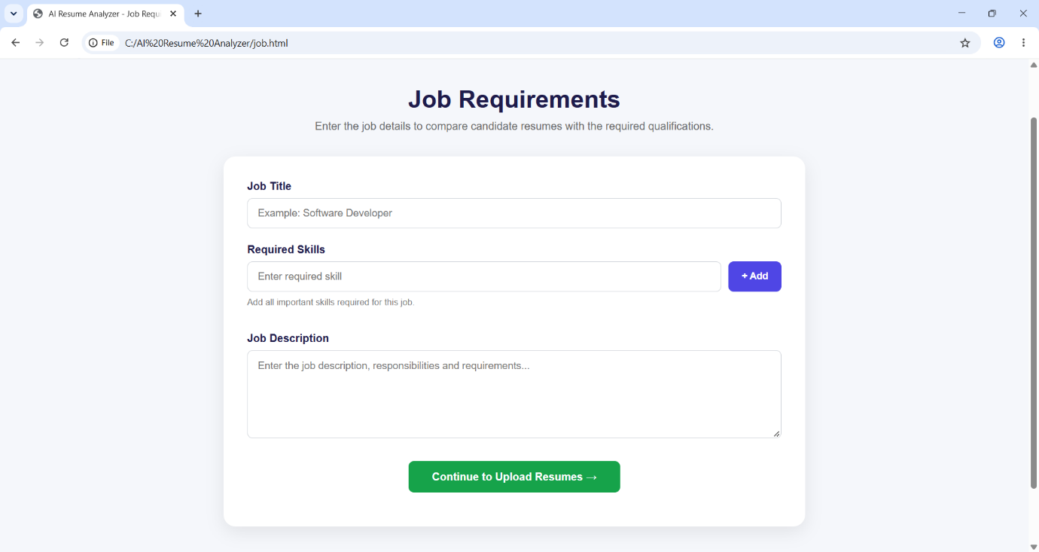

Analysis Page:
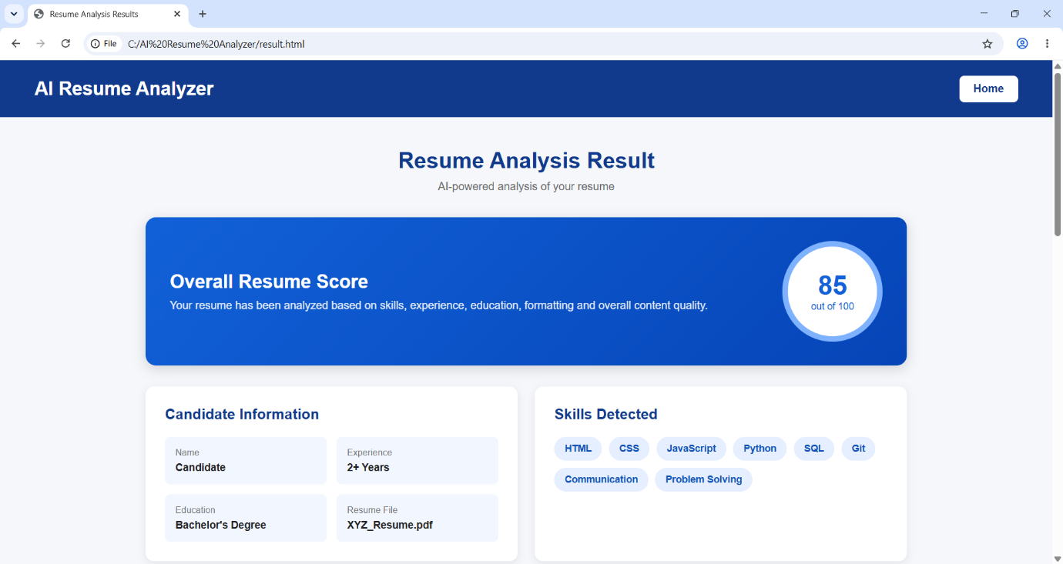

Upload Page:
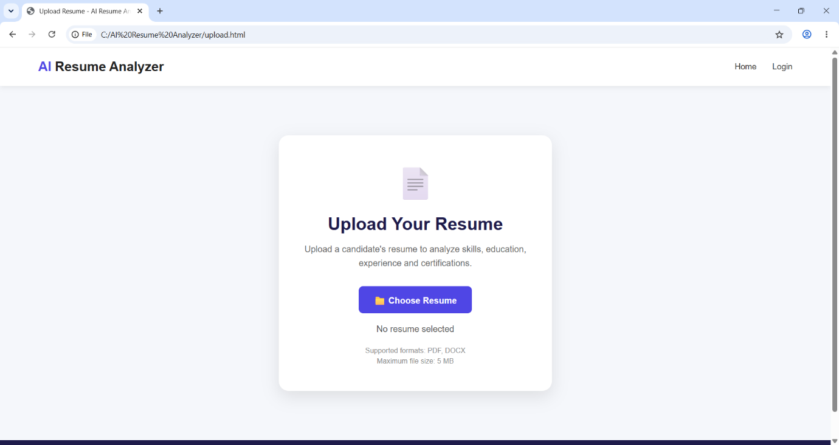

IMPLEMENTATION DETAILS
The AI Resume Analyzer system is implemented as a web-based application. It helps recruiters analyze resumes according to job requirements, calculate ATS scores, and rank candidates.

Technologies Used:
  - HTML
  - CSS
  - JavaScript
  - Python
  - Flask
  - MySQL
  - PDF and DOCX Processing Libraries
  - Web Browser

Software / Hardware specification

- Software Requirements:
  - Operating System: Windows 10/11
  - Frontend Technologies: HTML, CSS, JavaScript
  - Backend Framework: Python Flask
  - Database: MySQL
  - PDF Processing: pypdf
  - DOCX Processing: python-docx
  - Code Editor: Visual Studio Code
  - Web Browser: Google Chrome or Microsoft Edge

- Hardware Requirements:
  - Processor: Intel Core i5 or equivalent and above
  - RAM: Minimum 4 GB
  - Hard Disk: Minimum 10 GB of available storage
  - Input Devices: Keyboard and Mouse
  - Output Device: Monitor or Laptop Display

SYSTEM OUTPUTS AND VALIDATION

Output Screen: The Analysis page displays the results generated by the system. The output may include:
- Total number of resumes analyzed.
- Highest ATS score.
- Candidate rank.
- Resume file name.
- Total ATS score out of 100.
- Category-wise score breakdown.
- Matched skills or keywords, where available.
- Strengths, weaknesses, or suggestions, where available.

- Input Validation: Input validation helps ensure that the system receives acceptable data. The system should validate the following:
  - Registration and Login: Required fields should be checked before processing.
  - Job Requirements: The job title and job description should not be empty, and required skills should be entered in the expected format.
  - Resume File Type: Only supported PDF and DOCX files should be accepted.
  - File Readability: Empty, corrupted, or unreadable documents should be handled with an appropriate error message or safe fallback.
  - Job ID: The system should use the correct saved job when analyzing resumes.
  - Resume IDs: The selected resume records should correspond to the intended user and analysis request.
  - Database Errors: The application should display understandable error messages without exposing sensitive configuration details.

  - Report Format: The analysis report can contain the following information:
- Job Title.
- Resume File Name.
- Candidate Rank.
- ATS Score out of 100.
- Skills Match Score.
- Experience Score.
- Education Score.
- Certifications Score.
- Keywords and Format Score.
- Matched Skills.
- Missing Skills or Weaknesses, where available.
- Suggestions, where available.
The report helps recruiters understand how candidates compare with the selected job requirements.

CONCLUSION AND RECOMMENDATIONS, LIMITATIONS AND FUTURE SCOPE

- Conclusion: AI Resume Analyzer is a web-based project developed to simplify the initial resume screening process. The system allows recruiters to enter job requirements, upload multiple resumes, extract readable text, compare resumes with job criteria, calculate ATS-style scores, and rank candidates. The project demonstrates the practical use of HTML, CSS, JavaScript, Python, Flask, and MySQL in developing a recruitment-support application. The system can reduce repetitive manual screening work and help recruiters organize candidate information more efficiently. However, the scores should be treated as screening indicators rather than definitive judgments of candidate ability.

- Recommendation: The following recommendations can improve the usefulness and reliability of the system:
- Test the system using different job descriptions and resume formats.
- Verify that each analysis uses the correct Job ID.
- Display matched and missing skills clearly.
- Ensure that the ATS score breakdown is transparent.
- Validate uploaded files and handle errors properly.
- Protect candidate information and database credentials.
- Review the original resumes before making recruitment decisions.
- Perform testing before using the system outside the academic environment.

- Limitations: The current project has certain limitations:
- Rule-Based Matching: The system may not fully understand the context or meaning of every sentence in a resume.
- Keyword Differences: Related skills expressed using different terminology may not always be matched correctly.
- Scanned Documents: Image-only PDF files may require OCR for text extraction.
- Resume Formatting: Tables, columns, and unusual layouts can affect the extracted text.
- Incomplete Information: Some resumes may not clearly mention experience, education, or certifications.
- Score Accuracy: The ATS score depends on the programmed rules and does not guarantee that a candidate is suitable for a job.
- Human Review: The system cannot replace a recruiter's complete evaluation of a candidate.
- Prototype Limitations: Additional work may be needed to support large-scale deployment and advanced security requirements.

- Future Scope: The project can be enhanced in the following ways:
- Advanced NLP Matching: Use Natural Language Processing or semantic matching to understand related skills and job requirements.
- OCR Integration: Extract text from scanned resumes and image-based documents.
- Advanced Candidate Filtering: Filter candidates by score, skills, education, and experience.
- Downloadable Reports: Generate PDF or Excel reports of the analysis results.
- Analysis History: Store and display previous analyses.
- Multiple Job Management: Allow recruiters to manage several job openings and their associated candidates.
- Detailed Feedback: Explain why a candidate received a particular score and identify missing skills.
- Improved Dashboard: Provide charts and summary statistics for candidate analysis.
- Security Enhancements: Add stronger access controls, secure file retention, and audit logging.
- Fairness and Transparency: Evaluate the scoring process for unfair outcomes and ensure that final recruitment decisions remain under human control.

BIBLIOGRAPHY AND REFERENCES
The following official documentation resources are relevant to the technologies used in the project.
- Python Software Foundation. Python Documentation. https://docs.python.org/3/
- Pallets Projects. Flask Documentation. https://flask.palletsprojects.com/
- Oracle Corporation. MySQL Reference Manual. https://dev.mysql.com/doc/
- pypdf Documentation. PDF Text Extraction Library. https://pypdf.readthedocs.io/
- python-docx Documentation. Word Document Processing Library. https://python-docx.readthedocs.io/
- MDN Web Docs. HTML, CSS, and JavaScript Documentation. https://developer.mozilla.org/
- Project Source Code. AI Resume Analyzer application source code and database schema developed for this academic project.

